General Problem Solving Strategies | Order of Operations Symbols
- Read/reread the problem for understanding.  - Identify what the question is asking.  - Make a plan to solve the problem. (Choose at least one strategy.)  - Draw a picture.  - Create a table, chart, or list.  - Look for a pattern.  - Work backwards.  - Write a number sentence or an equation.  - Solve the problem.  - Reread the problem | PEMDAS  - Parentheses (brackets, etc.)  - Exponents  - Multiplication or Division (left to right)  - Addition or Subtraction (left to right)  GEMA  - Grouping  - Exponents  - Multiplicative operations (multiplication or division- left to right)  - Additive operations (addition or subtraction- left to right
Symbols | Divisibility Rules
- > is greater than  • < is less than  • = is equal to  • | 𝑥𝑥 | is absolute value of 𝑥𝑥  • ≥ is greater than or equal to  - ≤ is less than or equal to
  2 | If the last digit is even
  3 | If the sum of the digits can be divided by 3
  5 | If the last digit is 0 or 5
  6 | If the number is divisible by both 2 and 3
  9 | If the sum of the digits can be divided by 9
  10 | If the last digit is 0

Fractions | Properties
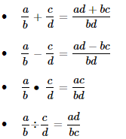 | 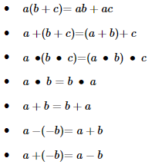

Statistics | Probability
- meAn-Average  - meDIan-Middle  - MOde-Most Often  - RangE- Least to Greatest | $$P=\frac{favorable outcomes}{possible outcomes}$$
Coordinate Plane
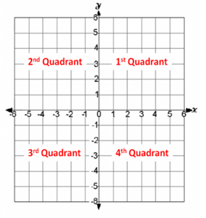
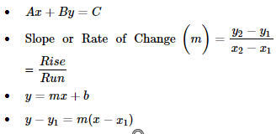

Place Value
Whole Numbers |  |  |  |  |  |  | Decimals
Hundred-  thousands | Ten- thousands | Thousands | Hundreds | Tens | Ones | . | Tenths | Hundredths

Transformations | Percentages and Proportions
- roTation -Turn  - reFLection -Flip  - tranSLation-Slide | - $\frac{is}{of}=\frac{\%}{100}$  - $\frac{a}{b}= \frac{c}{d} then ad=bc$

Hundreds Chart
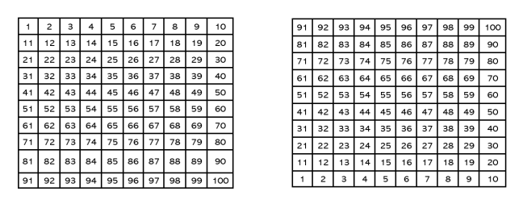

Geometry and Measurement
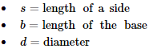
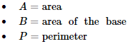
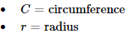
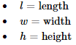
Number Line

