Resource Allocation Review Document for LEAs
version 3 - released February 2026

How Rhode Island is Addressing the Resource Allocation Review Requirements:
ESSA lays out specific requirements for Resource Allocation Reviews (RARs) for each level of the educational system – SEA, LEA, and schools. The figure below describes the federal requirement for each entity, as well as how these requirements will be met in Rhode Island.
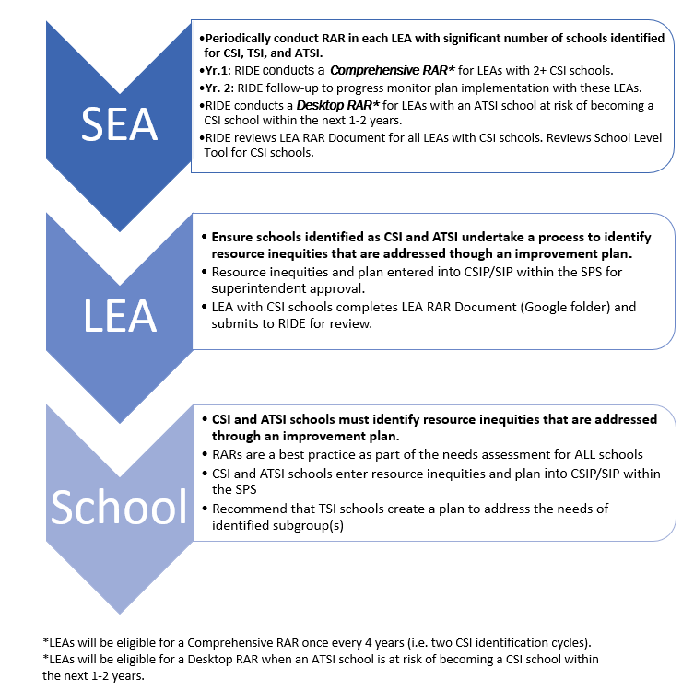

Often the barriers that prevent improvement of underperforming student subgroup(s) are the result of inadequate LEA systems and structures. Furthermore, a school cannot be improved on its own without support from LEA leadership. It is, therefore, the responsibility of the LEA to drive improvement efforts at the district level through the establishment of effective systems, structures, and enabling conditions to support the rapid turnaround required at a TSI/ATSI school.
Using the District Report Card, LEAs can find the list of schools with student subgroups identified for TSI and/or ATSI. This information can be found by clicking the Accountability tab, then by clicking the School Summary tab.

Center for School Turnaround & Improvement
Four Domains for Successful and Sustainable Improvement
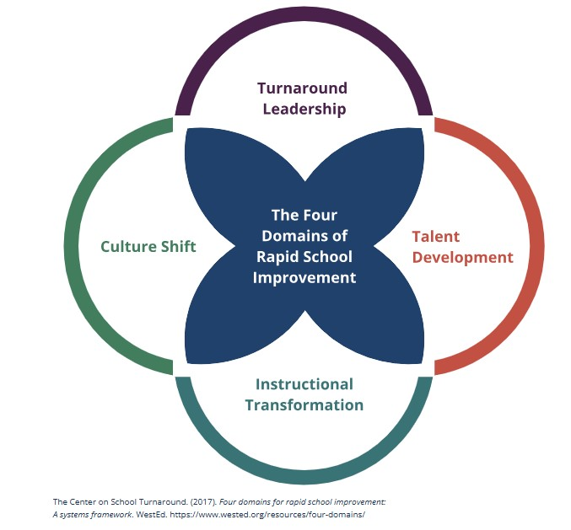
The Center for School Turnaround and Improvement (CSTI) emphasizes leveraging The Four Domains for Rapid School Improvement— Turnaround Leadership, Talent Development, Instructional Transformation, and Culture Shift—to drive successful and sustainable school improvement. These domains provide a comprehensive framework and practices for systemic change for state, district, and school leaders. An effective turnaround plan should prioritize these domains; however, there is no set order for implementation. While these practices can be implemented simultaneously, prioritizing too many at once can be counterproductive (West Ed, 2017).
- Turnaround Leadership: Effective leaders establish a clear vision, build shared accountability, and make strategic decisions that align resources and priorities with improvement goals. They create structures for continuous learning and foster a collaborative environment focused on student success.
- Talent Development: This domain focuses on attracting, retaining, and supporting high-quality educators and staff. It includes professional development, coaching, and creating career pathways to ensure educators are equipped to meet students' diverse needs.
- Instructional Transformation: Schools implement evidence-based instructional practices tailored to the needs of all learners. This includes implementing and aligning high-quality curriculum materials (HQCM), assessments, and teaching strategies to high standards while ensuring responsiveness to student progress.
- Culture Shift: A positive, student-centered culture is essential for improvement. Schools must build trust among stakeholders, foster a sense of shared responsibility, and create a safe, supportive environment that values high expectations and continuous growth.

By integrating these domains into a cohesive strategy, schools can address challenges holistically, promote equity, and establish a foundation for long-term improvement. Components for the Resource Allocation Review Document for LEAs have been created in alignment with The Four Domains of Rapid School Improvement.

RIDE Supports for Completing the RAR Process:
LEAs can use RIDE’s Resource Allocation Review Process Guide and RIDE's UCOA Resource Allocation Dashboards when conducting their RAR. The Process Guide outlines the requirements and procedures for RIDE, LEAs, and schools in terms of conducting resource allocation reviews to supporting low performing students subgroups. LEAs are encouraged to think about fiscal and educational resources, such as: federal and local funding, staffing, schedule, supplies/materials, equipment, programs/services, community collaboration, partnerships, and facilities. These sources will assist when completing the RAR.

Resource Allocation Review Process
The following process will be utilized by RIDE when facilitating a Comprehensive Review for LEAs with a significant number of schools identified for CSI. LEAs are encouraged to follow the same or comparable process when conducting RARs within their district.
Steps to complete the Comprehensive Review include:
- LEA assembles a RAR team.
- The RAR team engages in the RAR Preparation and Steps for the RIDE Comprehensive Resource Allocation Review. (RAR Process Guide, p.10)
- The RAR team answers the questions outlined below while participating in the RAR Preparation and Steps for the RIDE Comprehensive Resource Allocation Review.
- A plan for addressing resource inequities may be included in the LEA Strategic Plan, and must be included in CSIPs/SIPs for identified schools.
- School(s) identified as CSI and schools with identified ATSI subgroups will provide evidence of the RAR process by completing fields within the SPS.
- RIDE will review the Resource Allocation Review Document for LEAs with CSI school(s).
Please complete the following questions:
Who participated in the RAR? Please include their name and role.
Narrative

Describe the RAR process, and name the student subgroup(s) identified as TSI/ATSI.
Narrative

What inequities emerged between schools? What inequities emerged within individual schools?
Narrative

Identify the possible reason(s) the inequities exist.
Narrative
Are there additional resources and/or LEA Strategic Plan revisions (goal, initiative, action steps) that are needed to address the resource inequities?
Narrative

LEAs with CSI schools will use this tool to meet their RAR requirements. LEAs with ATSI schools can elect to use this document to meet their RAR requirements.
The Center on School Turnaround. (2017). Four domains for rapid school improvement: A systems framework. WestEd. https://www.wested.org/resources/four-domains/
The purpose of the RAR document is to guide the conversation when identifying financial and educational inequities. LEAs should keep this completed document as evidence of a RAR.

