Resource Allocation Review Document for LEAs

How Rhode Island is Addressing the Resource Allocation Review (RAR) Requirements:
ESSA lays out specific requirements for RARs for each level of the educational system – SEA, LEA, and schools. The figure below describes the federal requirement for each entity, as well as how these requirements will be met in Rhode Island.
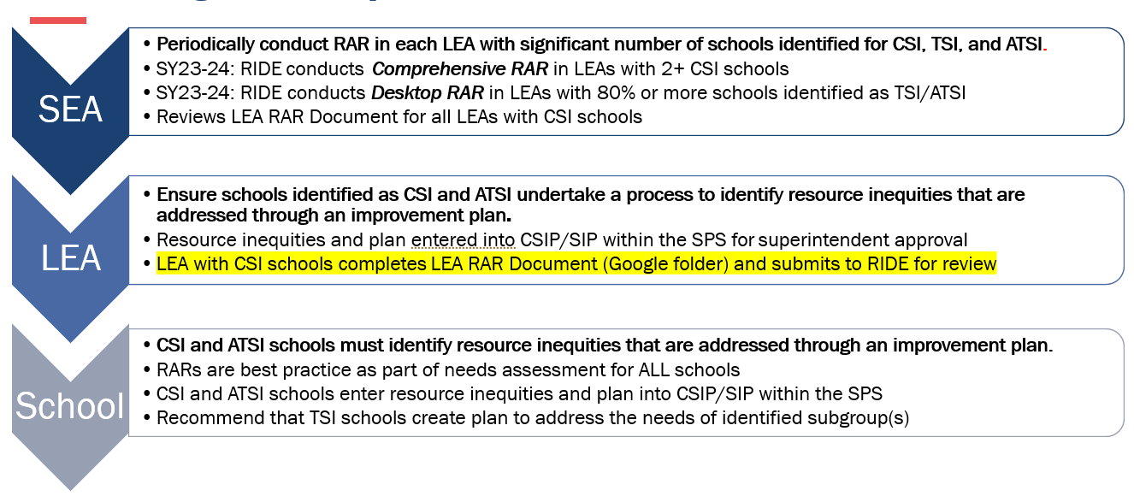
Using the District Report Card, LEAs can find the list of schools with student subgroups identified for TSI and/or ATSI. This can be found under the Accountability tab, then by clicking the School Summary tab.

RIDE Supports for Completing the RAR Process:
LEAs can use RIDE’s Resource Allocation Review Process Guide (coming soon!) and RIDE's UCOA Resource Allocation Dashboards when conducting their RAR. The Process Guide outlines the requirements and procedures for RIDE, LEAs, and schools in terms of conducting resource allocation reviews and supporting low performing students subgroups, as well as, assists in meeting these requirements. LEAs are encouraged to think about fiscal and educational resources, such as, federal and local funding, staffing, schedule, supplies/materials, equipment, programs/services, community collaboration, partnerships, and facilities. These sources will assist you when completing the RAR.

Resource Allocation Review Process
The following process will be utilized by RIDE when facilitating a Comprehensive Review for LEAs with a significant number of schools identified for CSI. LEAs are encouraged to follow the same or comparable process when conducting RARs within their district.
Comprehensive Review steps to complete the Resource Allocation Review include:
- LEA assembles a RAR team.
- The RAR team engages in the RAR Preparation and Steps for the RIDE Comprehensive Resource Allocation Review. (coming soon! - pages in the RAR Process Guide)
- The RAR team answers the questions outlined below while participating in the RAR Preparation and Steps for the RIDE Comprehensive Resource Allocation Review.
- A plan for addressing resource inequities may be included in the LEA Strategic Plan, and must be included in CSIPs/SIPs for identified schools.
- School(s) identified as CSI and schools with identified ATSI subgroups will provide evidence of the RAR process by completing fields within the SPS.
- RIDE will review the Resource Allocation Review Document for LEAs with CSI school(s).

Please complete the following questions:
Who participated in the RAR? Please include their name and role.
Narrative

Name the low-performing subgroups and describe the RAR process.
Narrative

What inequities emerged between schools within the LEA? Within the school(s)?
Narrative

Identify the possible reason(s) the inequities exist.
Narrative

Are there additional resources and/or LEA Strategic Plan revisions (goal, initiative, action steps) that are needed to address the resource inequities?
Narrative

LEAs with CSI schools will use this tool to meet their RAR requirements. LEAs with ATSI schools can elect to use this document to meet their RAR requirements.
The purpose of the RAR document is to guide the conversation when identifying financial and educational inequities. LEAs should keep this completed document as evidence of a RAR.

