Proctor Instructions:
Helping Students Take Online Surveys

Thank you for participating in this year’s SurveyWorks student survey program! As someone who will be proctoring surveys, you have an important role in this process. The goal of this document is to answer any questions you may have about the survey process and to give you the instructions you need to help students complete surveys successfully.
Please take about ten minutes and read this entire document prior to the first day of survey administration which is Tuesday January 18th, 2022.
This document contains three sections:
- About Online Survey Administration
- Proctor Instructions for Survey Administration
- Frequently Asked Questions

I. About Online Survey Administration

Students will take surveys online on Panorama Education’s secure website. This means that each student will need to have access to an Internet-connected device to take the survey. The survey is accessible via any Internet connection and will run on any web browser (Safari, Chrome, etc.). Students may use desktops, laptops, netbooks, Chromebook, tablets and/or mobile devices to access the survey.
You will have one access code that all of your students at your school can use to access the survey. This will be shared by RIDE in advance of the survey window.
Students will visit Panorama Education’s secure website, listed below, to take the survey(s). Each student will enter the access code on the Panorama survey website:

https://surveys.panoramaed.com/ride

This document gives step-by-step instructions for proctors, classroom teachers and survey coordinators about how to lead students through the online survey-taking process.
1
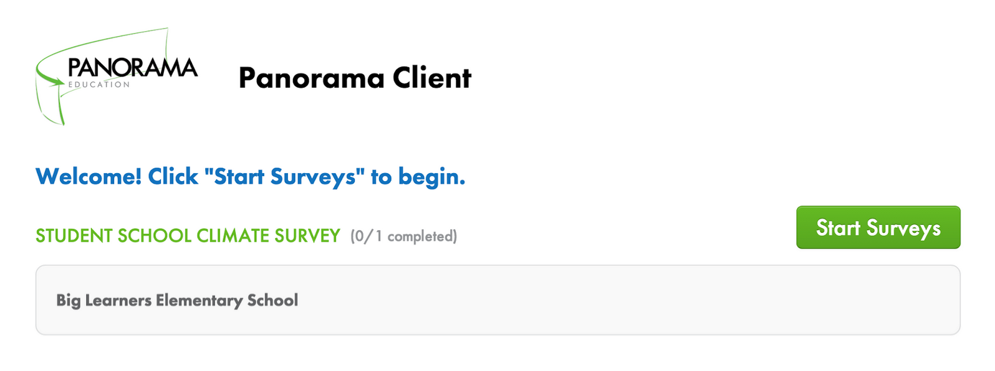
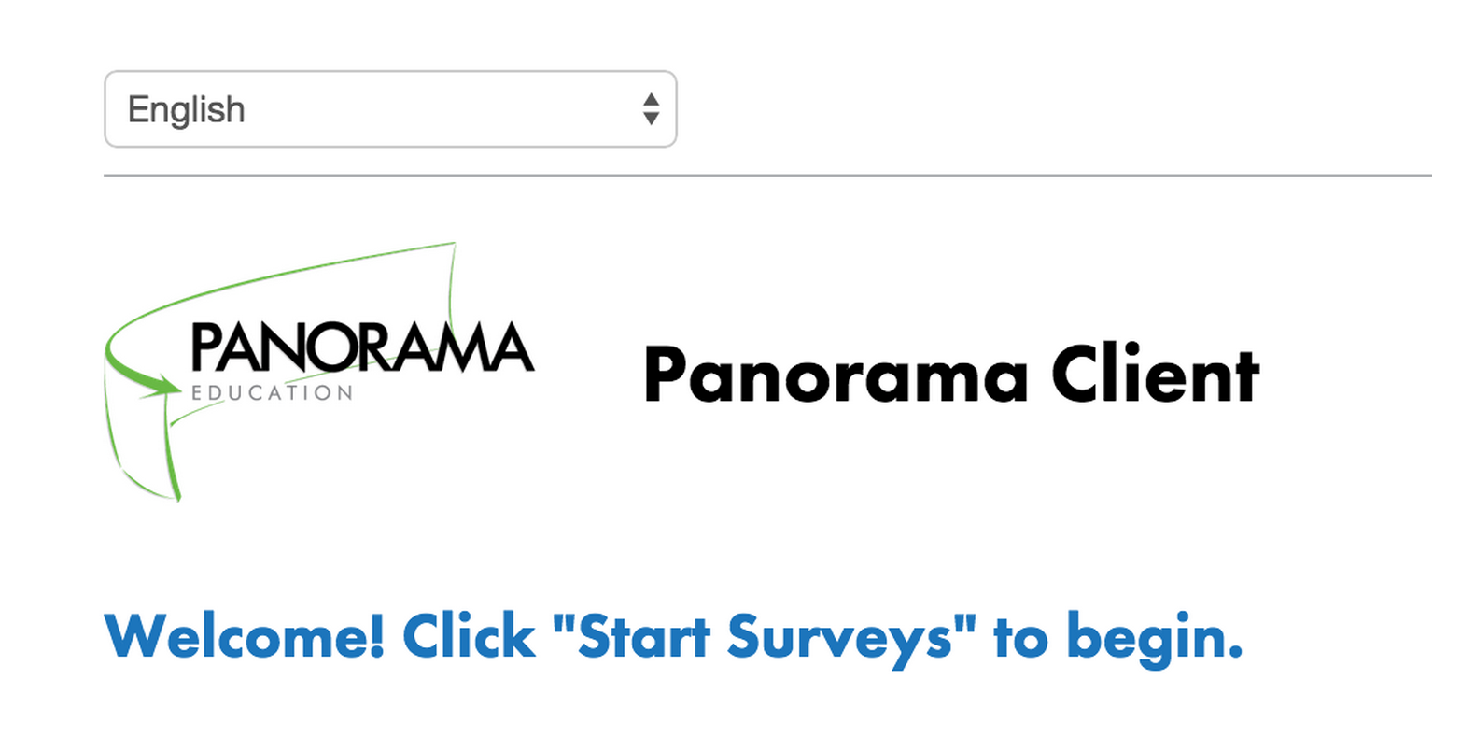
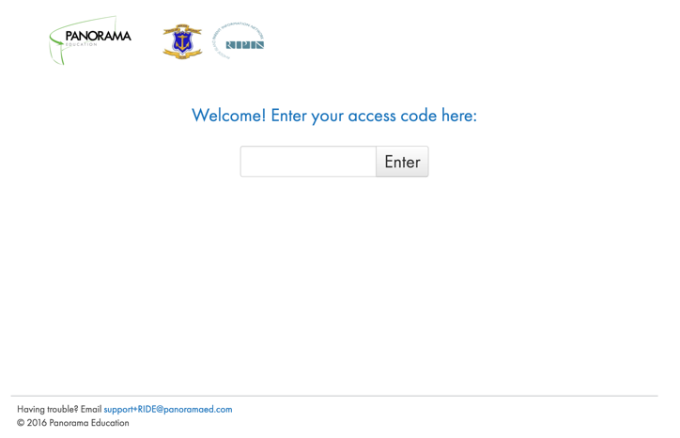

After entering access codes and clicking “Enter,” students will be directed to the survey selection page.

To start the survey, students will click the green button on the right side of the screen that says “Start Surveys.”
Students need to complete individual surveys in one sitting. Survey responses are saved once the student clicks on “Submit.” Students can continue to work on their surveys as long as they do not reload the page, or click on “Submit.” Partially filled-out survey forms won’t be saved and shouldn’t be submitted.
IA. Translations
The survey is available in English and Spanish. After students enter their access codes, they will be able to select an alternative language using the language selection button in the top left corner of the screen. (This button, shown below, lists the current language [e.g. “English”] with a dropdown arrow.)
2

II. Proctor Instructions for Survey Administration

You can help your school gain high-quality feedback data by setting a positive tone for the students taking the survey. We encourage you to explain that the survey is an opportunity for students to help teachers and administrators make their classes and school as a whole better. Students should be asked to take the survey seriously and told that their teachers will never be able to connect their answers back to them. The read-aloud directions that follow will remind students of these important details.
In addition to reading aloud these instructions, take care to create an environment that makes students feel safe while they take their survey(s). We encourage you to give your students space while they are completing the surveys. You might choose to stay at the front of the room and do work or read a book while students complete their surveys.
Before you begin talking to students about the surveys, take a moment to:
- Write the URL for the survey website on a chalkboard/whiteboard or pre-load the site onto each computer as a bookmark or homepage. The survey URL is: https://surveys.panoramaed.com/ride
- Write the correct access code on the chalkboard/whiteboard.
3
Proctor Script:

Today, you are being asked to answer questions about your experience as a student in this class and school. We are asking you to take this survey because your teachers want to hear from you!

As you complete your survey(s), remember that the purpose of the survey is to help us improve your learning experiences in school, so please be honest. Your teachers will not be able to connect your answers back to you. This survey is voluntary so you can skip any question or series of questions you can’t or don’t want to answer - and if you need help understanding what a question means, raise your hand and ask your teacher.

Now, let’s get started. Open your web browser. Type the website address on the board (point to URL) into your address bar. Press enter and wait for the survey website to load. Raise your hand if your page does not load and you need help finding the website.

You will see a box on the page that asks you to enter an access code. Type the access code into the box and click “Enter”.

Tips: Point to URL and access code and help any struggling students get to the website.

Once you have entered the access code, you will see a green button on the right side of the screen labeled “Start Surveys.” The name of the survey you are taking will appear in the list below. Please raise your hand if you do not see this page, if you are not enrolled in the class listed on this page or you don’t have the teacher listed on this page.

Help any struggling students enter their access codes.

After you have entered the access code, you can change to another language. In the top left corner of the screen, you will see a button that says “English.” To switch to Spanish, please click that button. Spanish will appear in a drop-down menu. Please select the language you would like to use from that list.

Assist any students with language accommodations to determine the appropriate language in which to take this survey, and have them click on the appropriate language from the drop-down menu. Help any student who does not see their school on the survey page.

Click on the “Start Surveys” button on the page. You will now be taken to the survey.
After answering all of the questions, click the blue button at the bottom of the screen that says, “Submit.”

Once you have completed your survey, please click the button that says “Submit.” When you see a final “Thank you” screen, it means you are done. Please read or work silently until all of your classmates have finished.

4

III. Frequently Asked Questions

What if a student can’t access the survey?
Double check the access code the student is entering. Be sure all digits are entered in the proper order, and enter zeroes if they are part of the access code (even when they are at the beginning). If the student still cannot access the survey, please reach out to support+ride@panoramaed.com

If a student enters the access code, and the browser freezes or crashes before the student can submit the survey, what should I do?
Please help the student close and re-open the web browser and access the survey website again. If the browser closes before the student submits the survey, the student can simply log on again with the same access code and try again.

If a student accidentally submits the survey before he or she is finished, what should I do?
Please contact the survey team at support+ride@panoramaed.com with the access code that the student used to submit a partial survey and the time it was submitted.

Thank you so much for your participation in this survey administration! We appreciate your help and support.
5

