**Grade 5 Student Work Samples (ePAT #5) for**

**RICAS Mathematics: Calibrating Expectations Using Existing Student Work Samples**

|  |
| --- |
| Sample A |

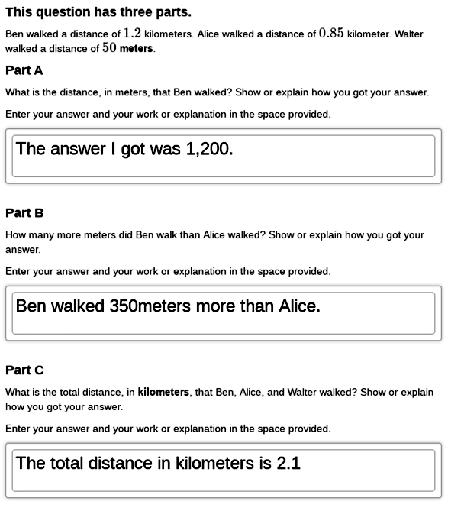

|  |
| --- |
| Sample B |

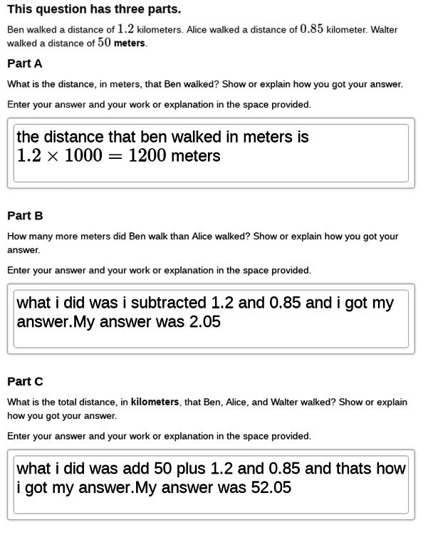

|  |
| --- |
| Sample C |

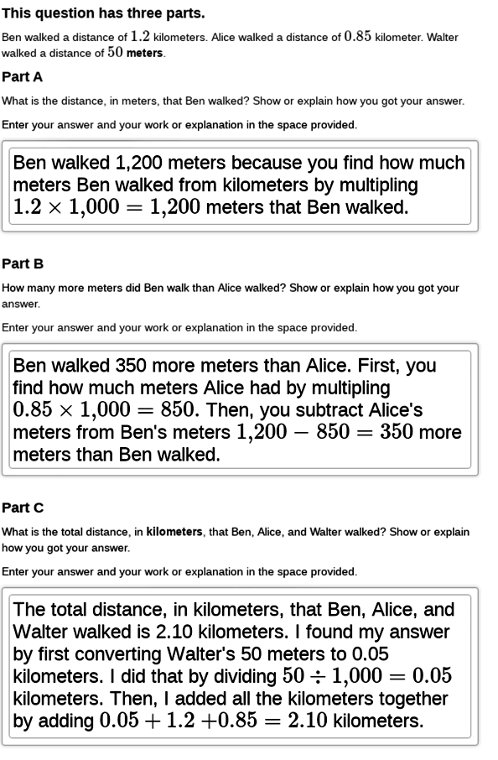

|  |
| --- |
| Sample D |

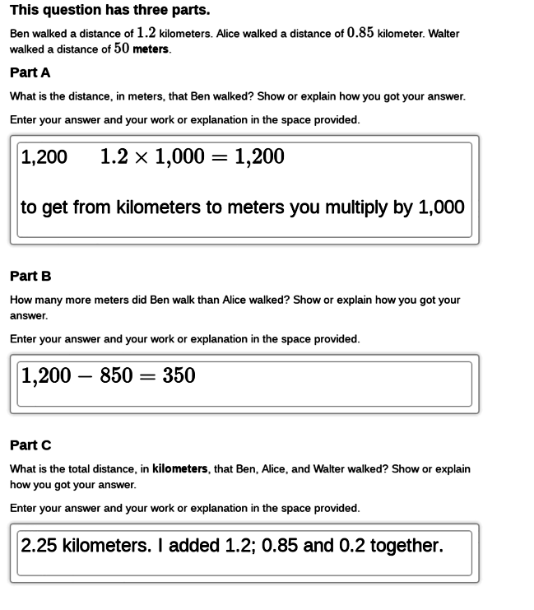

|  |
| --- |
| Sample E |

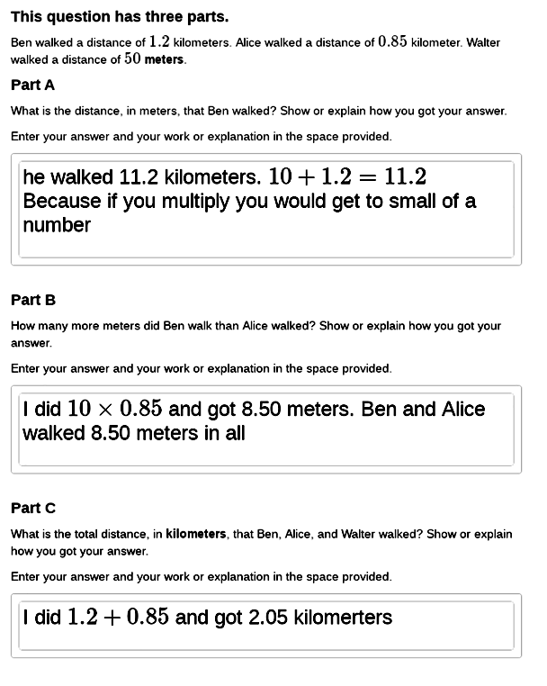

|  |
| --- |
| Sample F |

